**CHE517 ADVANCED PROCESS CONTROL**

**FINAL EXAM**

Professor Shi-Shang Jang Jan. 12, 2021

**Problem #1 Interpretation: (20%)**

(1) CV and MV

1. Feedforward Control
2. Relative Gain Array
3. State Space Model
4. Zero-order hold and sampling time

**Problem #2 (20%)**

Consider the following cold-hot water system with steady (initial) state and parameters

$${\overline{f}}_{C}=\frac{3m^{3}}{min}{\overline{f}}_{H}=\frac{1m^{3}}{min}, A=5m^{2}, T_{H}=80℃, T_{C}=25℃, \tilde{h}=4m$$

1. What is steady state temperature, *T* , of the tank?
2. Determine the relative gain array if ${MV}_{1}=f_{C}(t), {MV}_{2}=f_{H}(t), {CV}_{1}=h\left(t\right), {CV}_{2}=H\left(t\right)$, through MATLAB simulation.

**Problem #3 (20%)**

Derive a pulse transfer function (z-domain) for the following plants with a zero order hold and a sampling time of 1:

1. 
2. 

**Problem #4 (20%)**

Consider the following two input- two output System, determine the relative gain array

$$y_{1}\left(s\right)=\frac{2}{3s+1}m_{1}\left(s\right)+\frac{5}{s+1}m_{2}\left(s\right)$$

$$y_{2}\left(s\right)=\frac{4}{s+1}m_{1}\left(s\right)+\frac{1}{2s+1}m_{2}\left(s\right)$$

**Problem #5 (20%)**

Consider the control scheme for the solid drying system shown in the following Figure:

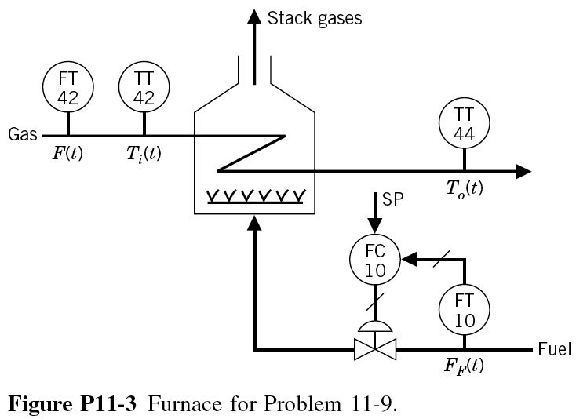

The major disturbance to this process is the moisture content of the incoming solids. For this disturbance, the control system responds quite slowly. It is desired to implement a feedforward system to improve this control. After some initial work, the following data have been obtained:

Step Change in inlet moisture=+2%

|  |  |  |  |
| --- | --- | --- | --- |
| Time (min) | Exit  Moisture, % | Time (min) | Exit  Moisture, % |
| 0 | 5 |  |  |
| 0.5 | 5 | 5 | 6.6 |
| 1 | 5.1 | 5.5 | 6.7 |
| 1.5 | 5.2 | 6 | 6.8 |
| 2 | 5.4 | 6.5 | 6.9 |
| 2.5 | 5.7 | 7 | 7 |
| 3 | 5.9 | 7.5 | 7 |
| 3.5 | 6.1 | 8 | 6.9 |
| 4 | 6.3 | 8.5 | 8 |

Step change in output signal from moisture controller, MC-10=+25%CO

|  |  |  |  |
| --- | --- | --- | --- |
| Time (min) | Exit  Moisture, % | Time (min) | Exit  Moisture, % |
| 0 | 5 | 5 | 3.81 |
| 0.5 | 5 | 5.5 | 3.7 |
| 1 | 4.95 | 6 | 3.55 |
| 1.5 | 4.93 | 6.5 | 3.45 |
| 2 | 4.85 | 7 | 3.35 |
| 2.5 | 4.7 | 7.5 | 3.25 |
| 3 | 4.6 | 8.5 | 3.1 |
| 3.5 | 4.4 | 9.5 | 3.03 |
| 4 | 4.2 | 11.5 | 3 |

Identify the control objective, the disturbance, and the manipulated variable.

(a) Draw a complete block diagram for this process that shows the effect of the inlet moisture on the controlled variable. Include all known transfer function.

(b) Develop a feedforward control scheme using the above data. (Hint: draw a step response plot, and find gain K, time constant τ and dead time D).

**Problem #6 (20%) Take home**

* Consider a plant with a transfer function of



1. What is the z transform of the plant?
2. In case the real transfer function is unknown, derive an approximate FOPDT transfer function using the reaction curve approach. What is the Ziegler-Nichols PID setting of the model?
3. What is the z transform of the FOPDT model?
4. What is the deadbeat controller of the FOPDT model? Compare the controller performance of the controller to the optimal PID controller using SIMULINK.